# Ultimaker 2 Experiences and Modifications

James Strawson 2015

University of California, San Diego

In April 2015 we took delivery of two brand new Ultimaker 2 desktop 3D printers to complement our overworked large-format printer. Our first impressions were positive. We enjoyed the clean user interface, solid construction, and especially the low-inertia X & Y axis mechanism. It is now October 2015 and we have put over 2000 hours of printing on each of them along with countless rebuilds. Along the way we have come to appreciate the many strengths of this design which have no-doubt been a result of the extensive testing and hacking of the original Ultimaker design by the open-source and DIY community. However, there are a couple of minor design faults which render the Ultimaker 2 unreliable and frustrating in a professional setting. Luckily these faults are cheap or free to remedy. In this paper we outline the various quibbles we have with the design of this printer and the steps we’ve taken to improve the performance and reliability. Along the way we will provide empirical test data to demonstrate the improvements along with discussion on our own failures along the way.

To help understand the component names used in this paper it is helpful to reference the Ultimaker 2 hardware documentation repository here <https://github.com/Ultimaker/Ultimaker2>.

## Thermal Improvements and Jamming

First I would like to start with a basic truth that explains the problems most people have when extruding PLA which has become the most popular plastic among the desktop 3D printer community. Within the hot end of every filament-fed FDM printer is a temperature gradient along the axis of the filament tube where the plastic transitions from solid to liquid. It is important that this gradient is as sharp as possible otherwise the filament will soften and expand under pressure to touch the inside of its guide tube. Usually this premature softening results in what we call jamming which is where the additional friction overcomes the feeder motor’s strength and plastic is no longer extruded consistently. In extreme cases the filament completely seizes in the hot end and must be melted out or forcefully removed. PLA suffers from jamming much more readily than ABS due to its lower melting temperature. This is not to be confused with clogging which is where a physical obstruction gets lodged in the small nozzle opening.

To keep this temperature gradient as sharp as possible, most hot ends employ active cooling in the form of a heatsink and fan right above the extruder nozzle and heater block. We have extensive experience with both the E3D V6 hot end and the Ultimaker 2 hot end, both of which have active cooling, and neither of which implement it properly. The E3D V6 includes a nicely designed heatsink with a ducted fan that ensures plenty of directed airflow over the heatsink fins. Sadly it is rendered mostly useless since the only surface contact the heatsink has with the heat break tube is a loose thread. The solution is simple: to fill the gaps of the thread with copious amounts of thermal paste. As an added measure we also heat up the aluminium heat sink with a hot air gun to about 150C before tightening the stainless steel heat break in place. When the heatsink cools it locks the threads tightly together preventing them from loosening during operation which would break what little thermal contact there is. I have added this procedure to the E3D wiki and have received considerable response from the online printing community confirming its effectiveness.

The Ultimaker 2 demonstrates the same thermal issue. About 40 minutes into a print we would consistently notice jamming and the part would be a complete failure. The problem is that the active cooling on the Ultimaker is not as active as you would think. The included 25mm 5V cooling fan is reasonably powerful, but is mounted flush against the heatsink in such a way that air is only allowed to flow through two of the eleven slots. To remedy this we designed a duct that spaces the fan 6mm back from the heatsink and allows airflow through all of the slots. This had the added bonus of reducing the noise generated by the fan for two reasons. Firstly the fan spins slightly slower based due to not being stalled from lack of airflow. Mostly the reduced noise is because the fan no longer rattles against the heatsink. The thermal performance gain from the duct immediately solved the jamming issue and we can now successfully complete >24 hour prints without overheating or jamming. The file for this duct is available on our GitHub repository linked at the end of this document.

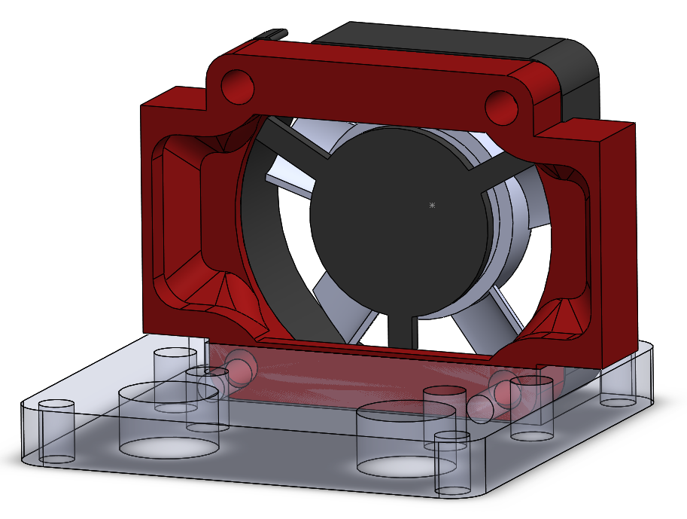

The Ultimaker factory uses copper grease between what they call the hot end isolator and the hot end holder bottom mount. This is very wise for two reasons. Firstly it provides lubricant for this part when it is turned for adjustment, and secondly it provides a necessary thermal interface to transfer heat from the isolator to the heatsink. Without it, jamming will occur even with the cooling duct. Normal CPU thermal paste seems to work equally well and we suggest cleaning the interface and reapplying thermal paste every time the isolator is removed.

Once the heat has transferred from the hot end isolator to the bottom hot end holder, it must still transfer to the heatsink. However, the bottom of the heat sink is very rough on both of our models and looked to be machined with a dull end mill without a finishing pass. For good measure, we also applied thermal paste between the heatsink and the bottom hot end holder to improve this necessary thermal contact. We cannot confirm if there is a real performance improvement from this as the duct solved the jamming issue completely. However, thermal paste is cheap and application is easy since you must disassemble the hot end assembly to apply the remainder of these modifications anyway.

## Friction Reduction and Feeder Reversal

With the duct installed and thermal paste applied, you should finally be able to print larger parts without jamming. Sadly, you will also discover that printing any faster than 20mm/s at standard 0.1mm layer heights will result the feeder motor skipping steps. Regardless of how slowly we printed, we found that plastic would extrude very inconsistently and while parts may look alright, they would lack structural integrity and are therefore useless for engineering prototypes. This is what the Ultimaker community calls underextrusion which is caused by friction and rough passage of the filament through the Bowden tube while under pressure.

We give credit to YouMagine member Pikita for providing a volumetric speed test for the Ultimaker that slowly ramps up the extrusion rate from 3mm^3/s to 10mm^3/s to measure the limit of the printer. This part is available here <https://www.youmagine.com/designs/test-print-for-ultimaker--2>. There is also a lengthy community discussion here: <https://ultimaker.com/en/community/view/5586-can-your-um2-printer-achieve-10mm3-s-test-it-here>. From reading this thread we gather that factory-spec Ultimaker 2 printers vary greatly in the speed they can achieve and that many struggle to achieve 4mm^3/s even when running the hot end much hotter than normal at 230C. The creator of this test recommends running this test at a nozzle temperature of 230C but we find this a little unrealistic for PLA prints as that temperature will quickly cause plastic degradation and carbon buildup in the nozzle. We personally have found 210C to be the ideal PLA temperature on both our Ultimakers from the perspective of both extrusion consistency, layer bonding, and surface quality. However, neither of our Ultimakers could reliably extrude even 3mm^3/s at 210C so we kept with the recommended 230C for the time being.

As a quick experiment we added a thin coating of oil to the inside of the Bowden tube. Immediately the printer was able to extrude at 4mm^3/s. This slight but distinct improvement was evidence enough for us to pursue more permanent friction reduction methods. We do not recommend oiling the tube whatsoever as it quickly resulted in gunky buildup on the inside of the nozzle.

The standard feeder arrangement and spool holder places the knurled feeder wheel on the outside of the natural bend of the filament. Since the knurled feeder wheel is of particularly poor design it chews up the filament where it is in contact, especially if the part requires a lot of filament retractions. The filament twists such that its natural bend matches that of the Bowden tube. The friction of the chewed-up side of the filament against the inside of the entire feeder system when under pressure has proven to be the single largest contributor to poor performance. Luckily the entire filament assembly is reversible which places the smooth unmolested side of the filament in contact with the Bowden tube while under pressure.

All that is necessary is to remove the 2 M3 screws holding the left motor cover on and the 4 M3 screws holding the feeder mechanism to the back of the printer. After screwing the feeder mechanism back on in reverse, it is then necessary to reverse the direction of the feeder motor to compensate. This is a quick adjustment in software. At the end of this paper you will find a link to our GitHub repository with this and other necessary changes. With this change implemented, the friction of the filament through the entire mechanism was reduced so greatly that our volumetric speed test was now capable of printing 9mm^3/s at 230C, a threefold increase from the factory configuration. We confirmed this on both printers with both white and blue filament to be certain. Here are pictures of both the new feeder orientation and the new test pieces demonstrating the speed improvement.

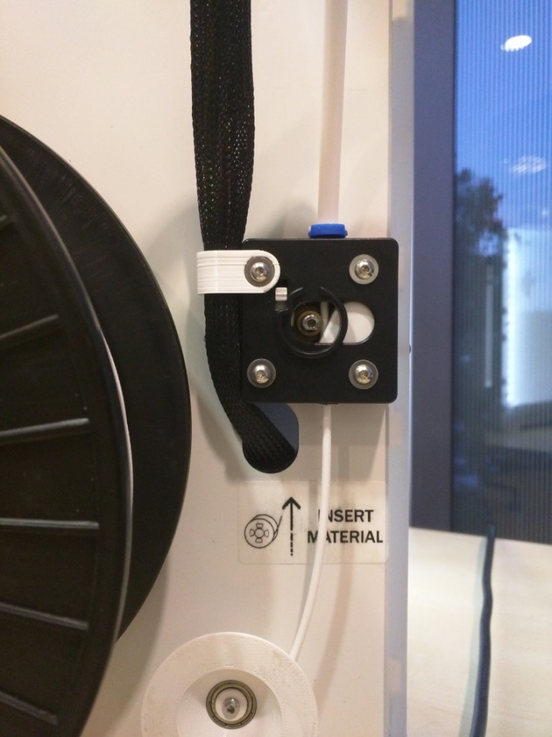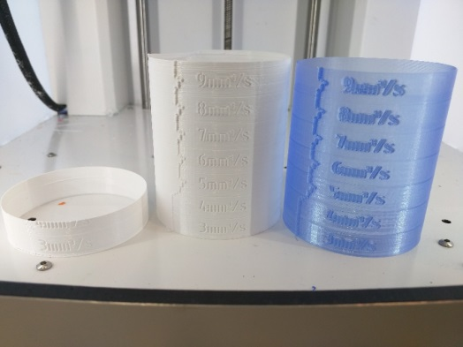

## Hobbed Wheel Upgrade

Even with this large reduction in friction, we wished to replace the poorly designed knurled feeder wheel with something that would both be less likely to grind straight through the filament and would reduce the slight slipping that results in inconsistent filament feed rate. We found that the hobbed feeder wheel design from the RepRap Mendel open source printer was a perfect fit on the Ultimaker 2 and resulted in much improved performance. This part is available from many sources on the internet, but we purchased ours from the Signwise here: <http://www.amazon.com/gp/product/B00XP3NJSE?psc=1&redirect=true&ref_=oh_aui_detailpage_o01_s01>.

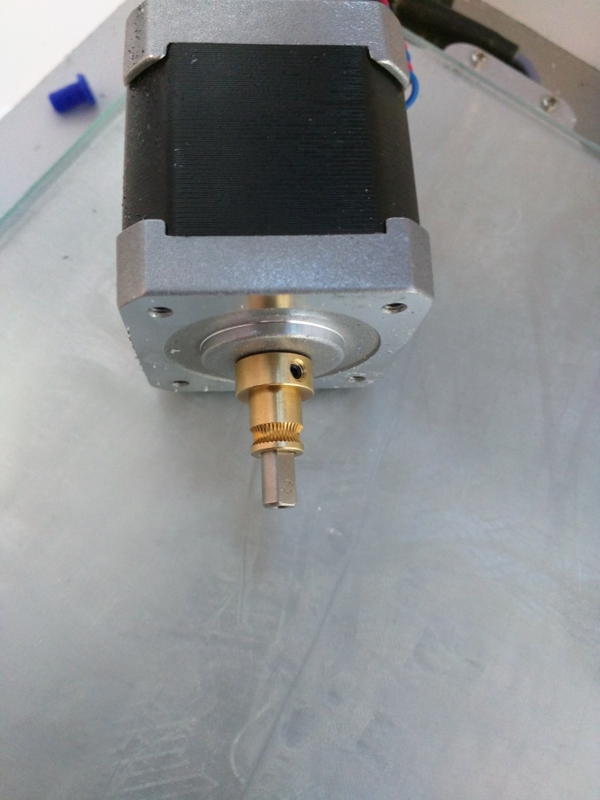

Instead of a sharp knurled surface which tends to wear away at the filament, this hobbed wheel actually wraps around the curvature of the filament providing much more surface contact and improved grip. Since it wraps around the contour of the filament it is possible to apply much more spring preload to the feeder bearing reducing the likelihood of slipping when the printer inevitably jams or clogs. We found that mounting it on the feeder motor shaft with 0.5mm clearance to the motor housing gave the correct offset to center the filament in the feeder mechanism. The above picture demonstrates correct mounting orientation.

The smaller diameter of the hobbed wheel means that it is necessary to run more spring preload in the feeder mechanism to achieve the same pressure. The Ultimaker manual suggests running as little preload as possible because any more will simply increase the rate at which the standard knurled feeder wheel chews through the filament. The hobbed wheel does not suffer from this problem and we can take advantage of higher pressure to reduce the chance of slipping. We have found that setting the preload at the second notch from the bottom is sufficient.

The new hobbed wheel measured 6.7mm diameter at its smallest point. The knurled wheel measured 7.9mm so we started by adjusting the steps/mm by the ideal ratio. The default is 282.

282*7.9/6.7 = 332.5 steps/mm

To test, we set the extrusion multiplier in our slicer to 1.00 and printed 20mm test cubes at solid infill to determine the exact steps/mm constant that gives us the best result. We did this process in parallel with both of our printers, one running undersized filament and the other running oversized filament. In both cases we did measure the filament diameter across a few points and entered this into the slicer. This tuning process is particularly important because there is less slip with this new feeder arrangement and slip is also a major contributor to the real-world feed ratio. The distance the knurling sinks into the filament and measurement error will make a difference. The ideal ratio of 332.5 was close, we experimentally found 327 steps/mm to give the best results on both printers and both filaments. The final change can be seen in our GitHub repository.

We were pleasantly surprised to see our experimentally determined steps/mm was within one percent of the calculated value. With the standard knurled wheel we had to run a 1.04 extrusion multiplier even when printing slowly and 1.08 when pushing as quickly as possible. With the new hobbed feeder wheel 1.00 gives us ideal results regardless of printing speed. This indicates considerable slip with the original feeder wheel.

## Increasing Feeder Motor Torque

The smaller diameter of the hobbed applies more linear force to the filament for the same feeder motor torque. The added grip of the hobbed wheel also allows us to increase the feeder motor torque without fear of chewing through the filament. Now we sought to achieve the highest feed extrusion rate possible while printing at the more realistic temperature of 210C since we almost hit the 10mm3/s limit at 230C.

When the Ultimaker 2 was first released the feeder current was set to 1350ma from the factory. A recent software update reduced that to 1250ma in an attempt to reduce the number of user complaints of chewed filament. We actually increase this to 1500ma to increase the total available torque available. Even at this higher current, the stepper will still skip as a failsafe before the hobbed wheel slips on the filament. While the stepper driver ICs are rated for 2000ma the Ultimaker control board is not designed with sufficient cooling and we hit the thermal protection safety at 1700ma.

We attempted to disable microstepping in hopes of gaining a bit more torque but this seems to be hardwired on the control board as firmware changes had no effect.

Before increasing the stepper current we were able to print 9mm3/s successfully at 230C but only 6mm/s at 210C. With the current increased to 1500ma and microstepping disabled we can now easily extrude 10mm3/s at both 230C and 220C. The 220C test pic pictured below on the left. Finally we can consistently extrude 8mm3/s at 210C as pictured below and on the right. Note that the 9mm3/s level is underextruded but still holds together without complete structural failure.

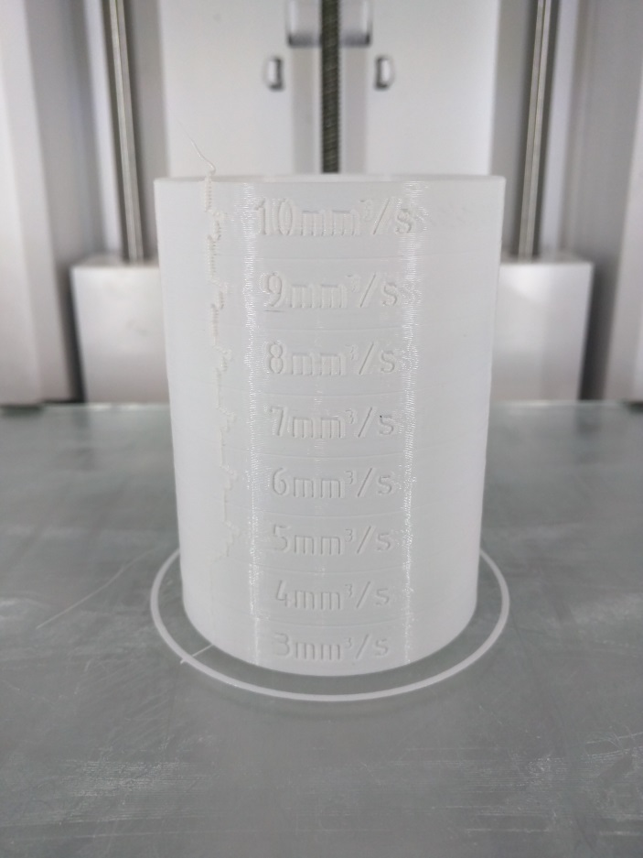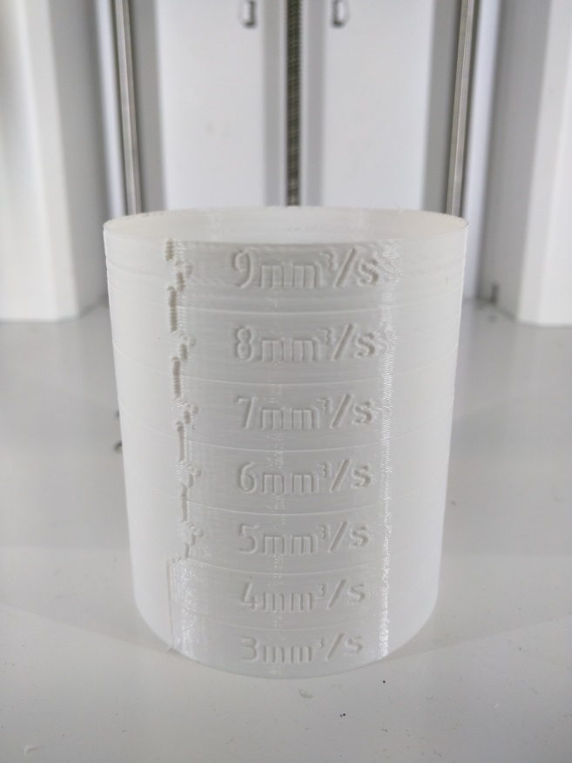

## Filament Guide and Spool Holder

During this tuning process we were also very careful to measure the filament diameter and make the appropriate change in our slicer settings for every test. We also noticed that the angle at which the filament entered the feeder make a slight difference as well as the bend radius of the filament. Thus, we pursued a filament guide setup that would provide more consistent results. The main improvement was installing a ball-bearing mounted spool just beneath the feeder mechanism using an existing hole that is used for the motor cover. In this convenient position the filament now feeds straight into the feeder mechanism instead of being tugged at an angle. While we were making improvements, we also made a second ball-bearing guide to replace the standard black plastic guide which had worn straight through as the filament simply grinds against it.

These spools are available on our GitHub along with the other components here. We designed them with a probably unnecessarily large flange to help keep the filament from slipping off when shifting the printers around or when the spool gets nudged. After two failed prints due to the filament slipping off the guide we arrived at this solution and have not had a single failure since.

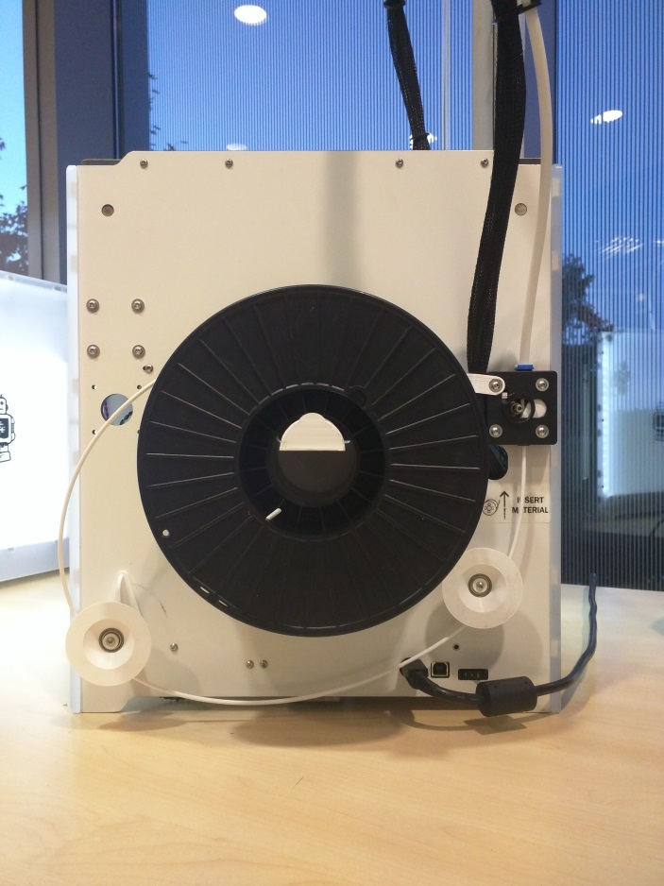

The standard spool holder also bothered us. Firstly it squeaked badly, and secondly its diameter was so large that most of our spools would not fit. YouMagine community member Solonari designed a very nice replacement that solves both of these problems as is available here: <https://www.youmagine.com/designs/ultimaker-2-36mm-spool-holder-v1-2>. We found that the small tab stopping the spool from sliding off was a little too small and broke easily so the version on our GitHub repository is strengthened.

YouMagine user Izzy also designed a nice clip to hold the Ultimaker wiring harness out of the way of the filament and the moving spool. There is no performance improvement to be had but it keeps the back of the Ultimaker neat and tidy and is well worth the 10 minutes it takes to print the part. It really bothers me that the wiring harness rubs against the filament from the factory. Reversing the feeder mechanism keeps this from happening but the harness still rubs on our larger spools so I highly suggest using Izzy’s design available here: <https://www.youmagine.com/designs/wire-retainer-clip>.

We only use one of these on each printer and mount it on the top left corner of the feeder mechanism when looking at the back of the printer. It can be seen in the previous pictures.

## 

## Bowden Tube Replacement

We quickly discovered that the Ultimaker struggled to print in the back left corner of its print bed. This became very frustrating when printing large parts and batch prints. If one pays for a 23x22 cm bed then one should expect to be able to use all of it. The cause of this issue is that when printing in that far corner the Bowden tube is bent at a very tight radius. We sought to find a slightly longer tube which would be a drop in replacement and also provide less friction if possible.

Fluorotherm 1/8” ID PTFE tubing is a perfect fit for the Ultimaker Bowden clips. We ordered a 5 foot length and found that the 2.5 foot length achieved by cutting it in half was about 140mm longer than the Ultimaker Bowden tube. This was just enough added length to achieve consistent performance across the entire print bed and the tube has visibly less bend. Sliding the filament through by hand takes less effort than the standard Bowden tube also. This tubing is available here: <http://www.amazon.com/gp/product/B00KJDE67G?psc=1&redirect=true&ref_=od_aui_detailpages01>.

It is necessary to modify the tube stock slightly before installing it just like Ultimaker does. The feeder end needs to be countersunk at a 45 degree angle to allow new filament to feed in without catching on the edge when changing spools. It is also necessary to drill out the inside of the other end about 3cm deep with a 3/16” drill bit to prevent hot plastic from sticking to the inside when the printer retracts the filament after every print. We also beveled the outside edge of both ends of the tube to make inserting into the Bowden clips easier.

If your printer has been used a lot you may notice the tube has started to wobble in the clips slightly. The more play in the Bowden clips then the more retraction distance is necessary to both relieve the pressure off of the compressed filament and pull the filament back out of the nozzle slightly. The brand new tube should fit snuggly in the clips with zero movement up and down. The filament compresses significantly inside the tube when extruding quickly under pressure and the longer tube only increases this. Luckily the new hobbed feeder wheel allows us to use high retraction distances without chewing up the filament. We like to use 6.0mm of retraction and have found no reduction in stringiness by going higher.

The final modification that must be done to compensate for the longer tube is to increase the distance that the feeder pulls the filament out when changing filaments. This constant is called BOWDEN_FILAMENT_LENGTH in the firmware source code and we increased this distance from 705mm to 840mm in our GitHub Repository fork of the firmware.

## PTFE Isolator Coupler

About 500 hours into printing each of our Ultimakers demonstrated a sudden drop in performance. Furthermore, the filament would jam in the bowden tube after every print and would require manual removal and trimming. The reason for this is that the PTFE Isolator Coupler deforms over time from the heat of being in contact with the heater block. Ultimaker now consider this to be a wear item and charge $20 for a replacement.

Ultimaker community member Olsson designed and now sells a resilient insulator which installs between the heater block and the standard PTFE Isolator Coupler to extend the life of the coupler. This is called the I2K insulator as is available in Europe here: <http://3dsolex.com/i2k-insulator>. If you are in the US then community member GR5 sells these same parts at his store here: <http://gr5.org/store/index.php/um/i2k-insulator.html>. GR5 also sells the replacement isolator couplers for roughly half the price of the Ultimaker OEM replacement parts and they work equally well from our experience. GR5 is a helpful contributor to the Ultimaker 2 community and was one of the first people to be able to print at 10mm^3/s.

Olsson rightly suggests adjusting the height of the heater nozzle to be as high as possible by threading the steel hot end isolator all the way onto the heater block then backing off a quarter of a turn to prevent unnecessary thermal contact with the threads. This puts as much spring pressure as possible on the PTFE Coupler and I2K Insulator to prevent leaking. It also raises the PTFE coupler higher up into colder region of steel hot end isolator to reduce its temperature and make the part last longer. This may also serve to increase the temperature gradient as discussed in the thermal section of this paper but this is difficult to measure. Another benefit it that this prevents the heater block from touching the steel cooling fan duct which ours did from the factory. In addition to the loss in efficiency, we also found that the nozzle would drop in temperature by over 10 degrees as soon as the cooling fans turned on before the feedback controller brought it back up. With the added clearance this no longer occurs.

## Nozzle Cleaning

Every time we change filament colour we perform a cold pull to clean out the nozzle. We will also do this before rebuilding the hot end to remove all traces of plastic from the PTFE isolator coupler and the heater block. The basic procedure is documented all over the internet and has become common practice on all FDM printers. For the Ultimaker, our exact procedure is as follows:

1. Remove the Bowden tube from the top of the hot end.
2. Manually set the nozzle temperature to 210C in the Ultimaker 2 advanced menu.
3. Insert a piece of scrap white PLA into the nozzle which is at least 300mm long.
4. Press the filament in firmly and extrude about 40mm of filament to flush out old plastic.
5. Set the temperature to 75C and keep pushing filament through as it cools.
6. At around 110C the chance of air getting in is minimal and you can let go while it keeps cooling.
7. After it has settled at 75C for a couple minutes, tug the filament out quickly.
8. Make sure the hot end isolator has seated back into its groove in the bottom hot end holder. If it hasn’t, wiggle it back into place with a 2.5mm hex key.
9. If the white PLA pulled out a significant amount of black crud from the inside of the nozzle then repeat the process.

Turning the knob continuously to set the temperature can be rather annoying. YouMagine member Swonkie has designed a fantastic replacement knob available here: <https://www.youmagine.com/designs/ultimaker-2-knob--2>. This is a very nice touch to the printer and makes removing the knob easy if you want to keep people from fiddling with it during a print such as at trade shows.

## Retraction and Wipe Setting

With less play due to the nice new bowden tube we wished to retune the retraction distance that is just enough to stop stringiness. For this test we printed in parallel a 20mm cube along with nine 4x4x20mm columns so there would be plenty of retractions along with big and small islands to make sure extrusion was consistent across the whole print bed.

We started with the retraction settings that worked well for us with the default configuration: 6mm retraction, 0.5mm coast, and 2mm wipe. This was done using Simplify3D 3.0.2 for our slicer. We actually found that only 3mm retraction was now sufficient. Since Simplify3D now supports gentle retraction while wiping we increased the wipe to 3mm so the print head wouldn’t need to slow down as much for the wipe. We then quickly discovered that prints would underextrude in areas with multiple islands. Disabling the coast feature helped this slightly as plastic no longer stops extruding right at the end of each loop. The result was that all 9 thin columns and the 20mm cube would print completely solid with no skipped layers and each stood up to a quick bend test by hand. Previously parts with skipped layers would simply fall apart in your hand.

We finally discovered that while that test print worked perfectly, other real parts would still cause extruder jamming and underextrusion in areas with lots of islands. This appears to be a bug with simplify3D 3.0.2 as reported here <https://forum.simplify3d.com/viewtopic.php?f=9&t=3536>. The solution was to check the box for relative extrusion.

## Software Changes

The following software settings changes were necessary:

* Reverse feeder motor direction on line 325 of Configuration.h

#define INVERT_E0_DIR true

* Increase feeder motor current to 1450ma on line 207 of Configuration_adv.h

#define DEFAULT_PWM_MOTOR_CURRENT {1200, 1200, 1500}

* Change feeder motor steps/mm on line 366 of Configuration.h

#define DEFAULT_AXIS_STEPS_PER_UNIT {80.0,80.0,200,327}

* Increase retraction length when changing filaments on line 385 of Configuration.h

#define FILAMANT_BOWDEN_LENGTH 840

Much to our frustration we found that the feeder motor current and motor steps/mm are read in from the EEPROM on startup instead of from the firmware binary itself. Only after performing a factory reset do these changes take effect. Since we wished to flash new Ultimakers in one step we also added the following lines to the very end of the Config_RetrieveSettings() function at line 241 of ConfigurationStore.cpp to ignore what’s in EEPROM and load our new default settings instead.

//ignore EEPROM extruder steps/mm and current

float temp1[]=DEFAULT_AXIS_STEPS_PER_UNIT;

axis_steps_per_unit[3]=temp1[3]; //overide EEPROM steps

float temp2[]=DEFAULT_PWM_MOTOR_CURRENT;

motor_current_setting[2] = temp2[2]; // overide EEPROM current

## Failed Experiments

We have tried a couple of unsuccessful modifications which we would like to share with you here anyway. Our first attempt at fixing the underextrusion issues was to try the very popular replacement feeder by YouMagine user IRobertI here:<https://www.youmagine.com/designs/alternative-um2-feeder-version-two>.

It is nicely designed and we loved that it includes a quick release to pull the feeder bearing away and allow manual removal of the filament when the knurled feeder wheel grinds through the filament or gets jammed. However, it doesn’t offer any performance improvement nor does it address the fundamental problem with the feeder which is the knurled wheel itself. It also cannot be installed in reverse which is what helped us reduce the friction in the Bowden tube.

We also tried the fan ducts designed by YouMagine user mnis available here: <https://www.youmagine.com/designs/ultimaker-2-cpv9>. We loved that it allows you to throw away the 12 screws holding the cooling fans and the original duct in place which makes rebuilding the hot end much faster. We also love that it directs some of the cooling flow to the heat sink and the PTFE coupler which actually works so well that our previously discussed heat sink cooling duct was not necessary. In addition, the fans stick out less giving a few more millimeters of useable print bed on the right side. However, there are two issues. The small amount of plastic which is purged out at the beginning of every print is prone to getting caught in the ducts whereas the factory duct knocks that plastic off the side of the bed. More critically, when printed out of PLA these ducts tend to warp and sag after a couple hundred hours of printing. This was a neat experiment but there is really no reason to change the OEM cooling fan arrangement.

## Conclusion

To summarize we made the following hardware modifications in order of importance:

* Printed fan duct
* Feeder mechanism reversal
* New hobbed feeder wheel
* I2K insulator
* PTFE Bowden tube
* Ball bearing filament guide spools
* Thermal paste on heatsink and isolator
* Printed spool holder
* Printed control knob
* Printed wire clip

The combination of these small improvements has entirely fixed our complaints with the original Ultimaker 2 design. It can now extrude plastic over 3 times faster and with more consistency. Furthermore it is quieter when in operation and has not jammed or stripped the filament once since the modifications. Finally, we do not need to replace the PTFE coupler once every 6 weeks. None of these modifications were expensive or difficult, however the process was tedious and time consuming. We hope you, fellow Ultimaker 2 owner, can benefit from what we have documented here. We also thank Ultimaker for what we still consider to be one of the highest quality printers on the market but with the hope that these simple changes make their way into the OEM assembly procedure.

The CAD files and complete firmware source code required for the modifications documented here are all available here: <https://github.com/StrawsonDesign/Ultimaker2_Mods>